MIND TRACK
Step 1: Launch an EC2 Instance:
Install Git:
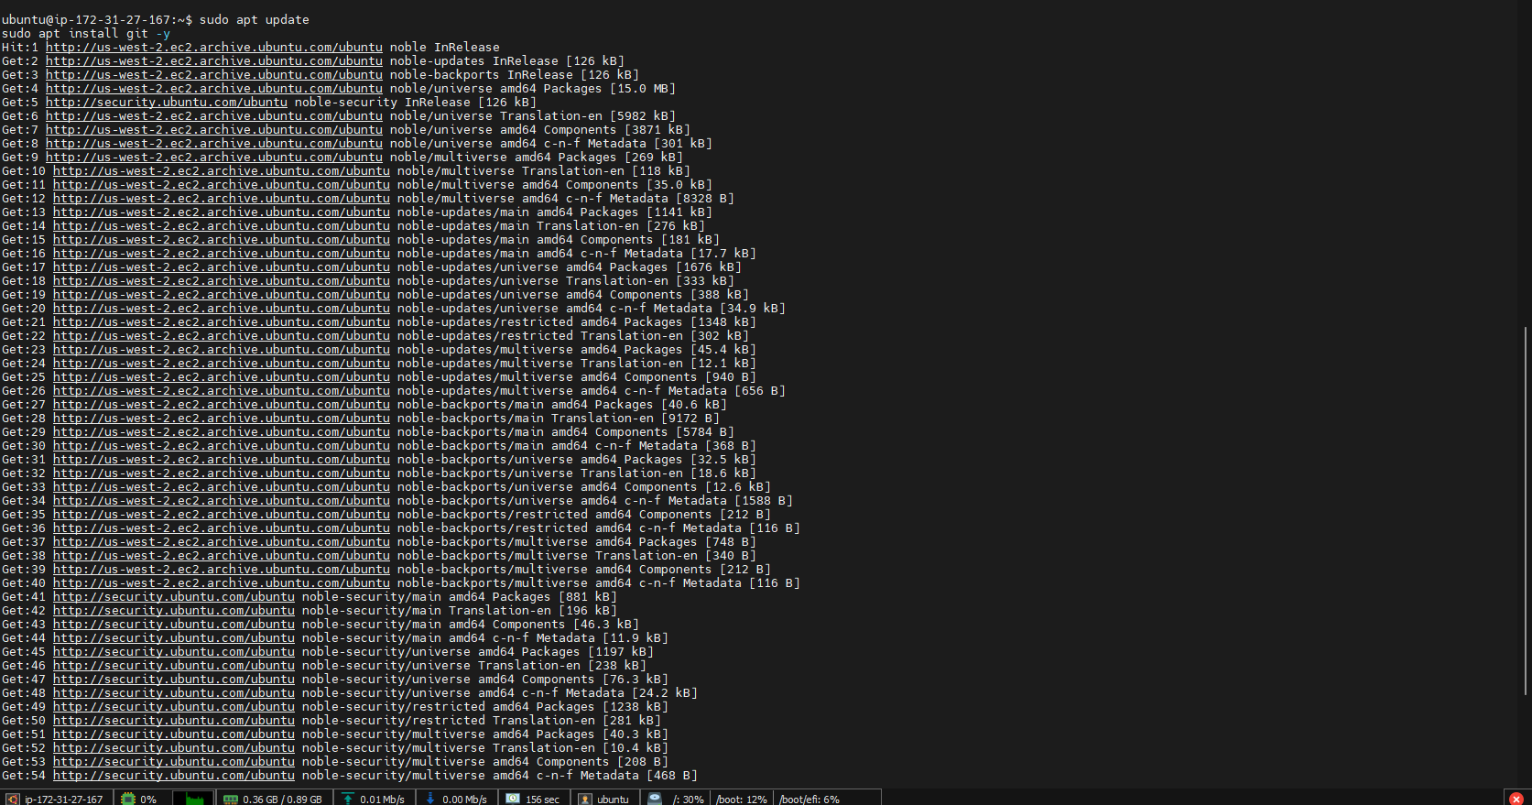
Install Docker:
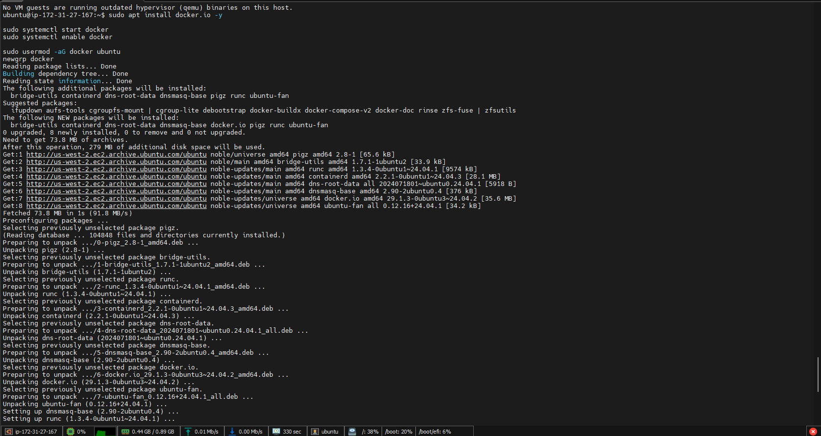
Verify installation:
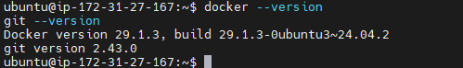
Step 2: Clone the Application:
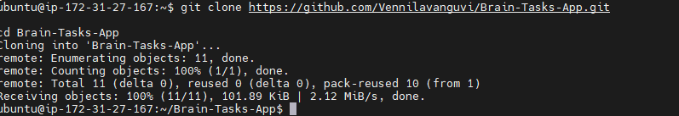
Verify:
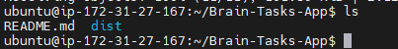
Step 3: Run the Application Locally using Docker(Dockerize the Application/Build Docker Image):
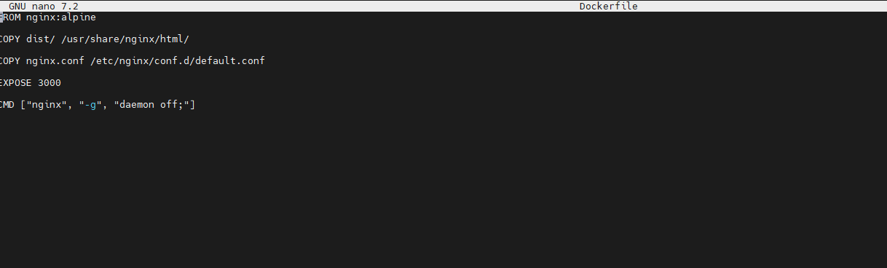
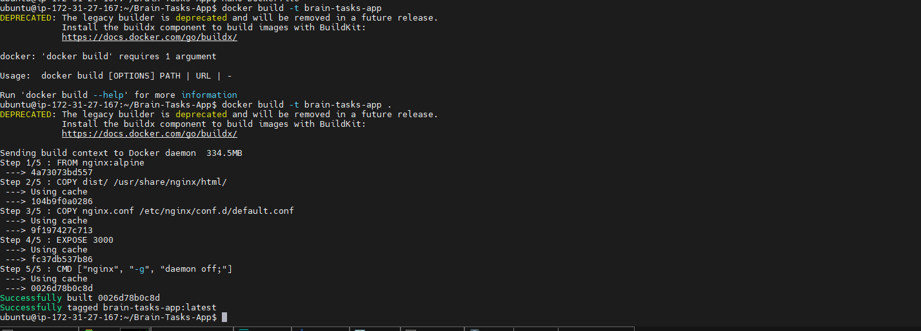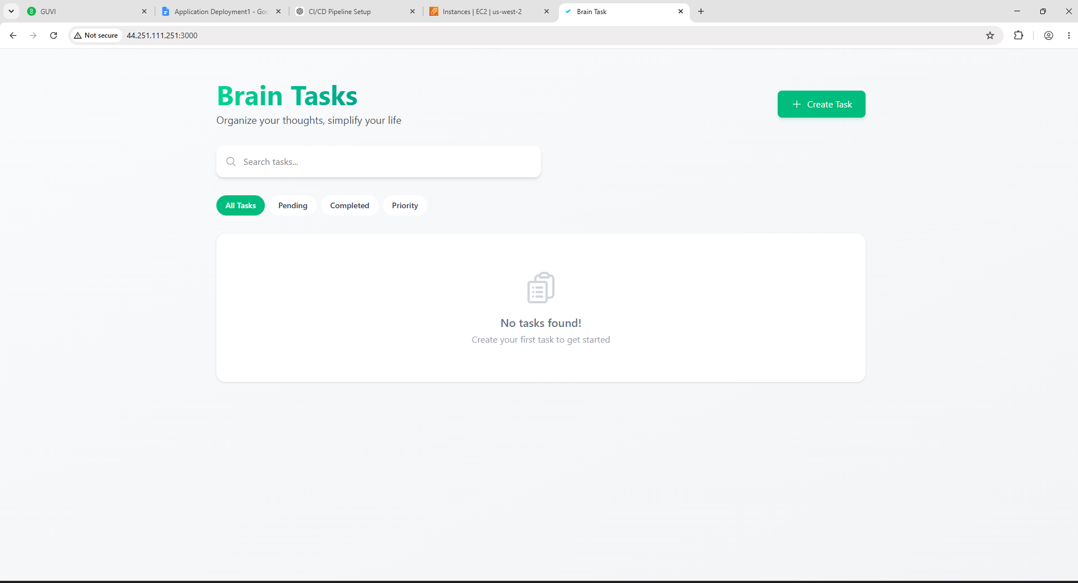
Step 4: Registry – Docker Hub:
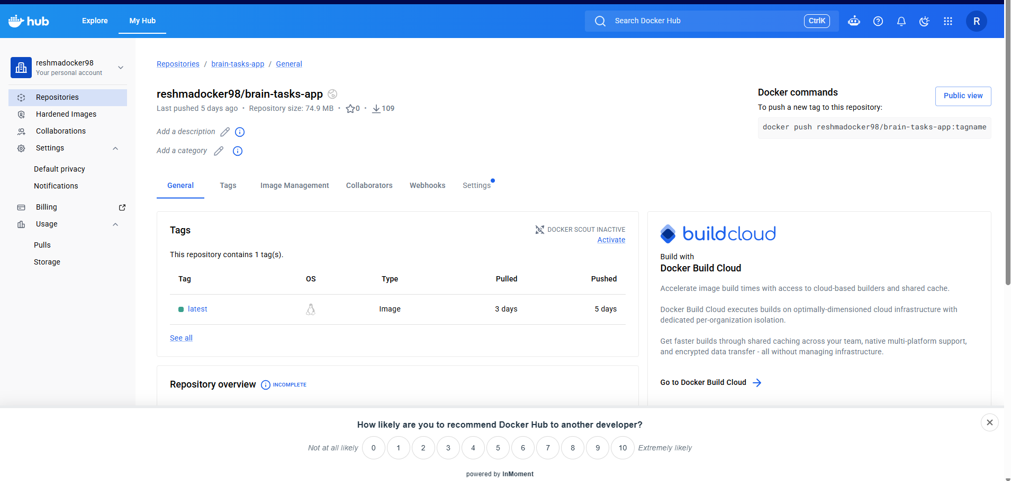
Login to Docker Hub:
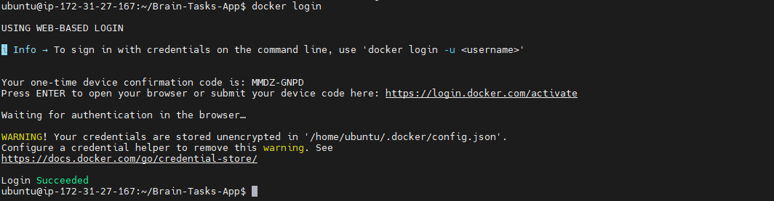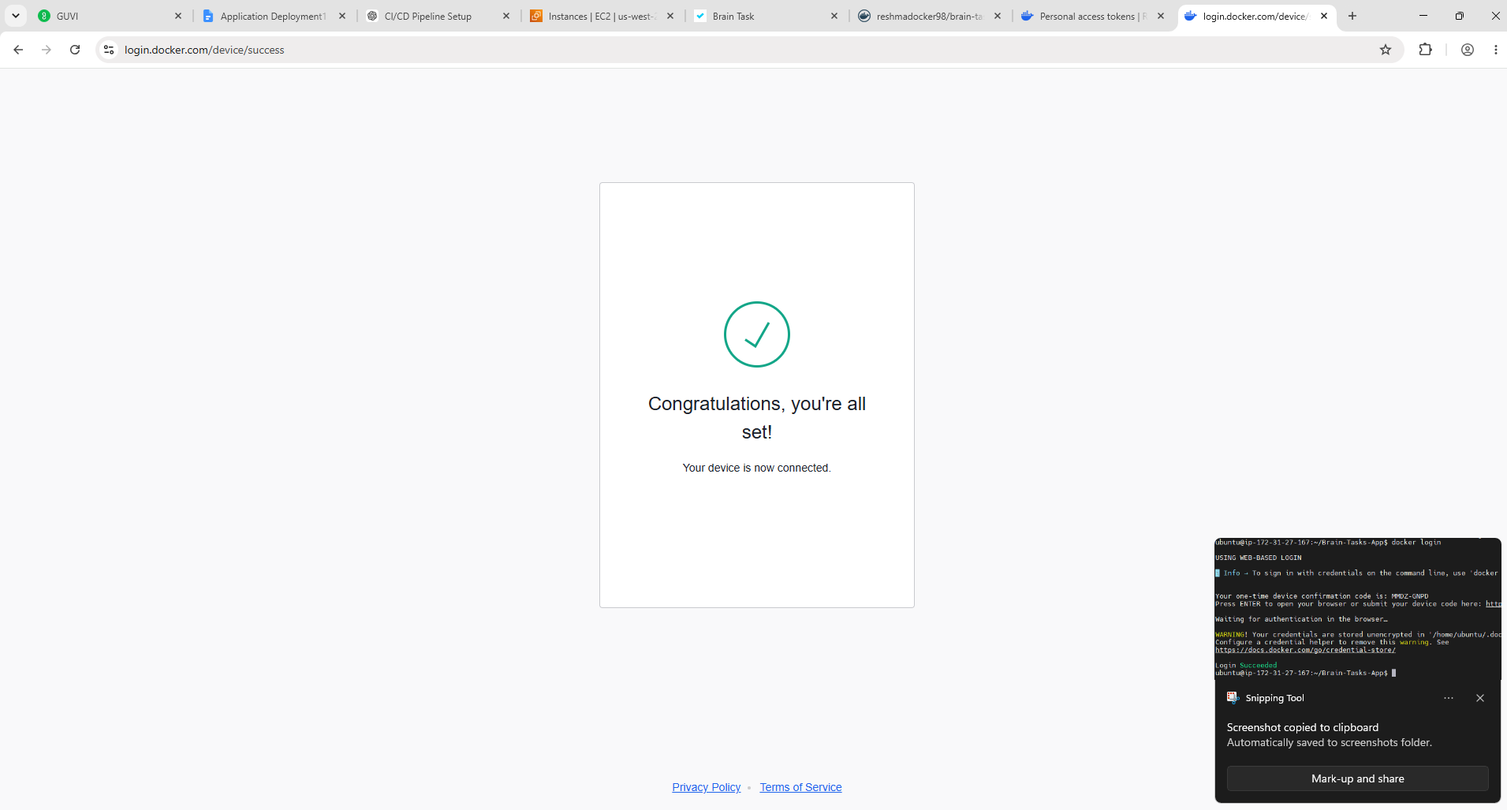
Tag the Image:
Push the Image:
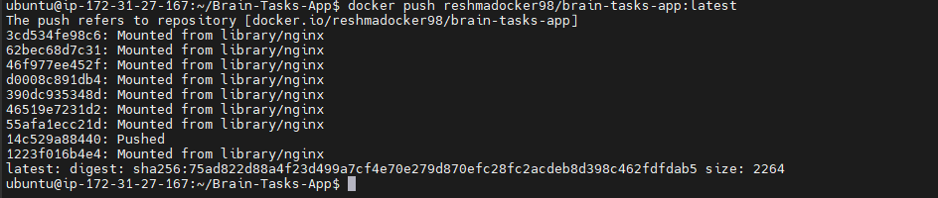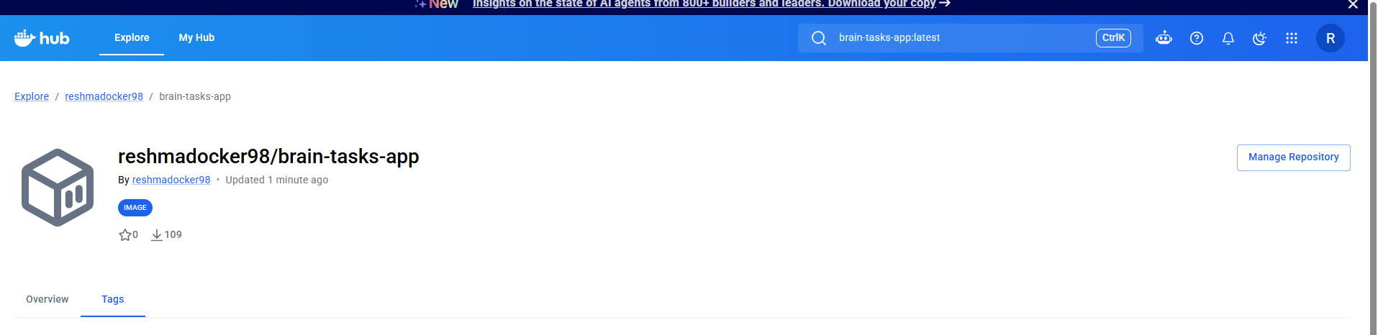
Step 5: Setup Amazon EKS:
Install eksctl:
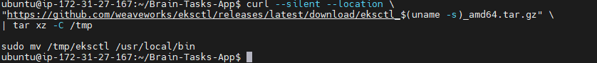
Install kubectl:
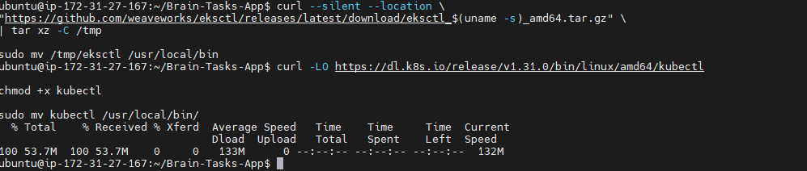
Install awscli:
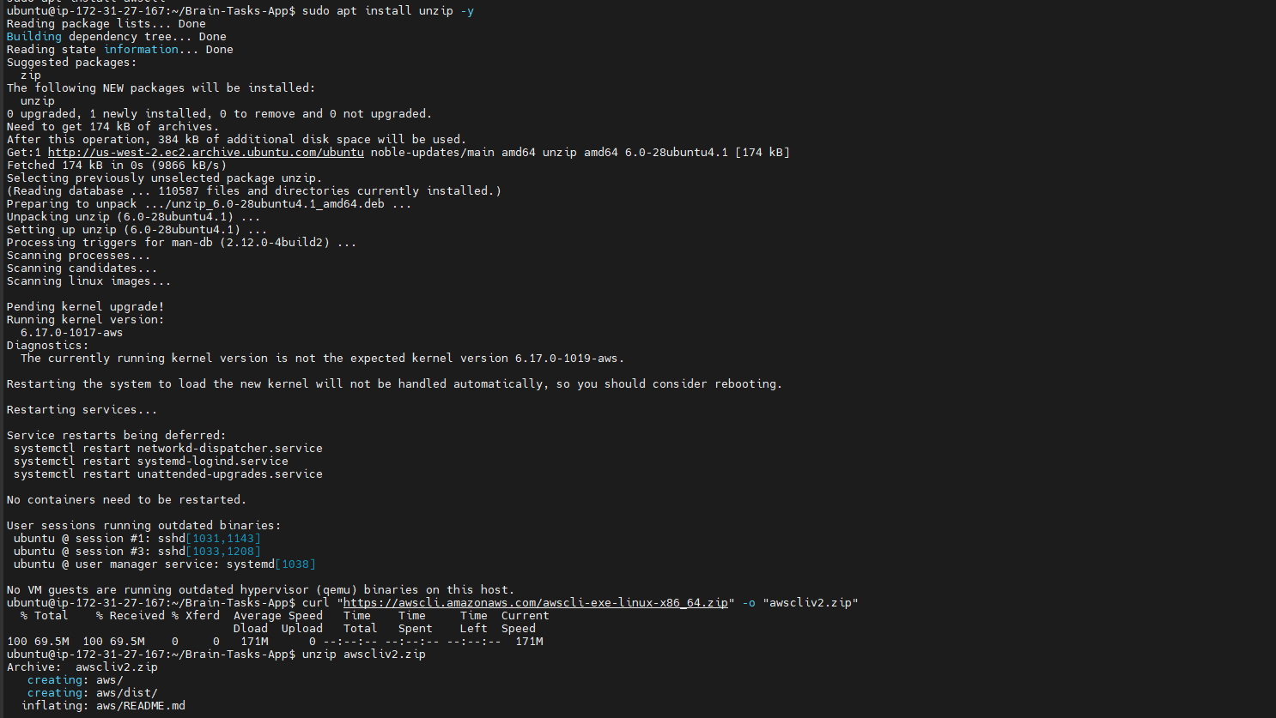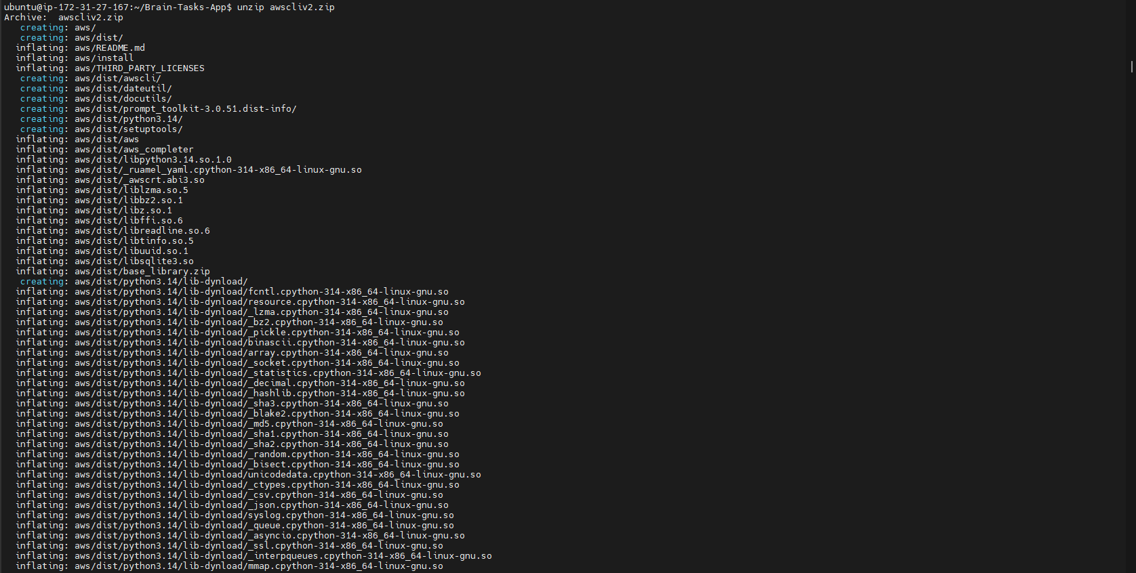
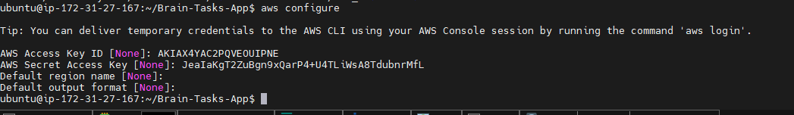
Create cluster:

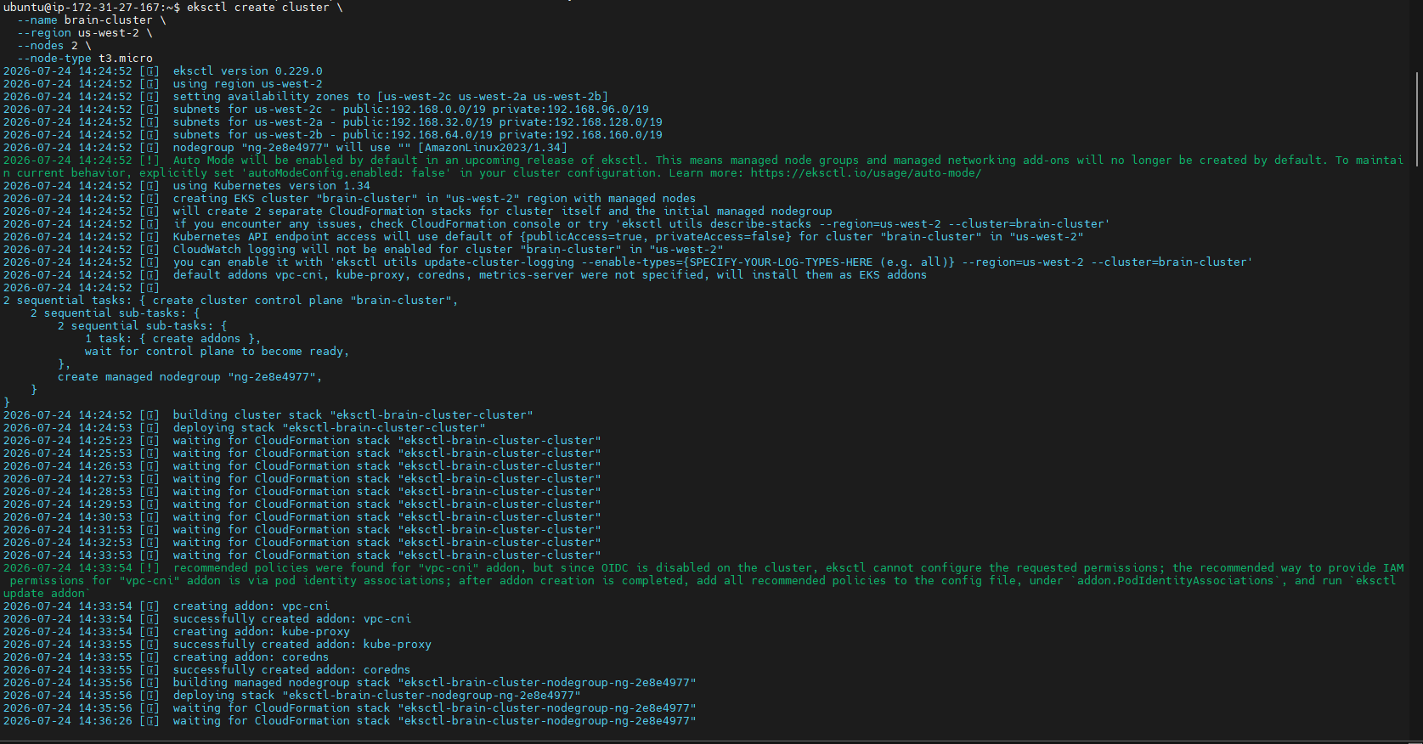
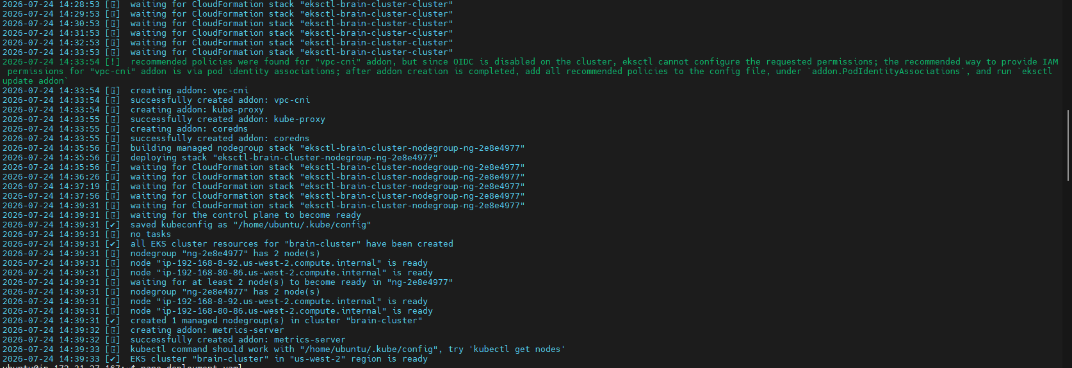

Step 6: Verify the EKS Cluster:
Configure kubectl:
Check nodes:
Step 7: Create deployment.yaml:
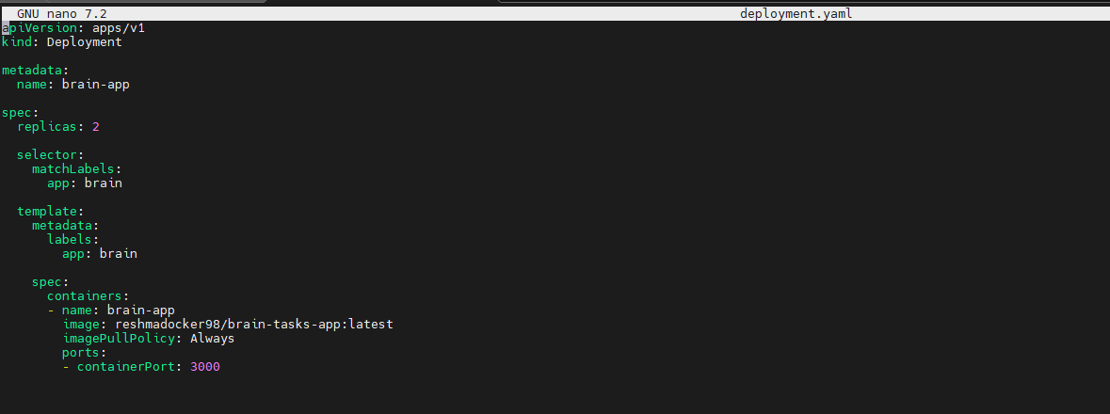
Step 8: Create service.yaml:
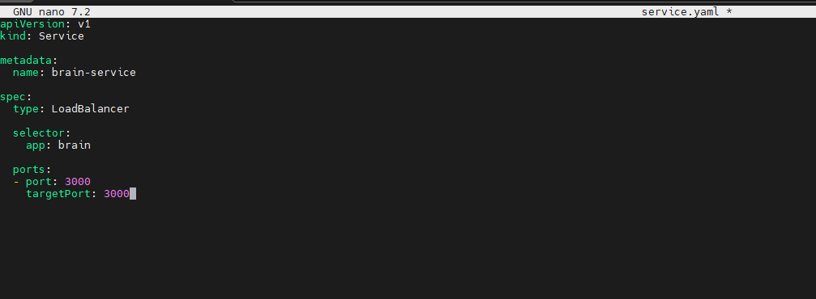
Step 9: Deploy to Kubernetes:
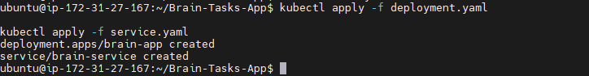
Verify:
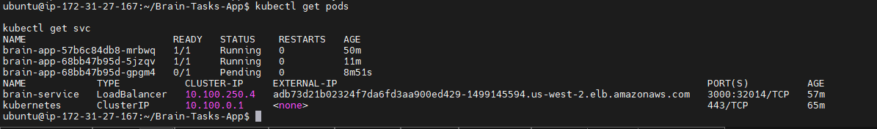
http://adb73d21b02324f7da6fd3aa900ed429-1499145594.us-west-2.elb.amazonaws.com:3000/
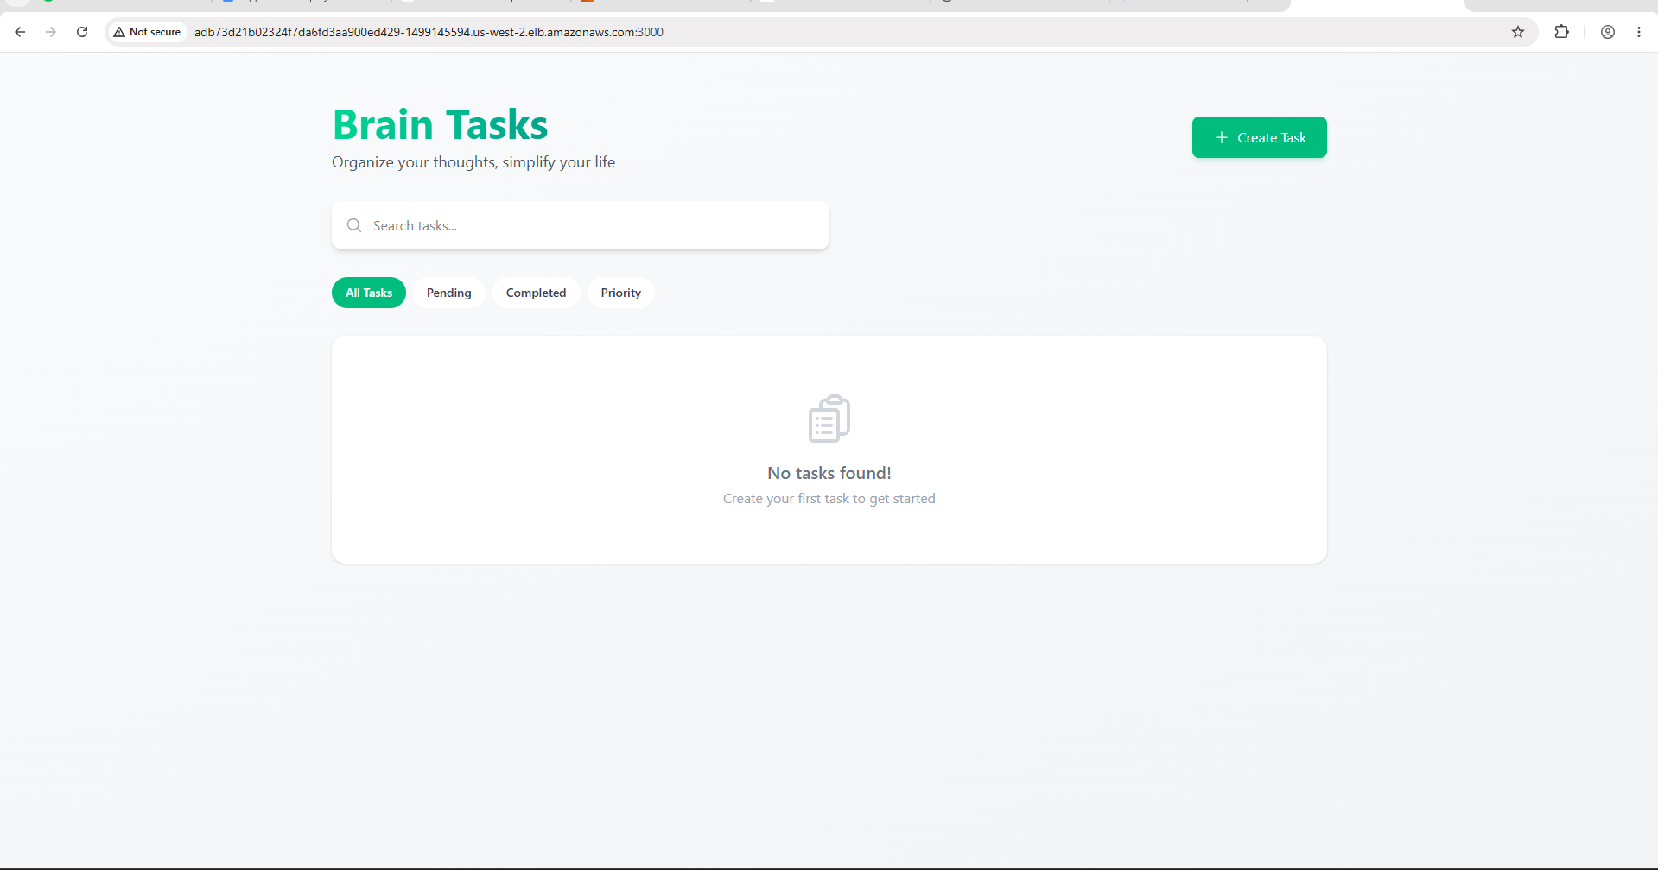
Step 10: Push Code to GitHub:
Initialize Git:
Commit and push:
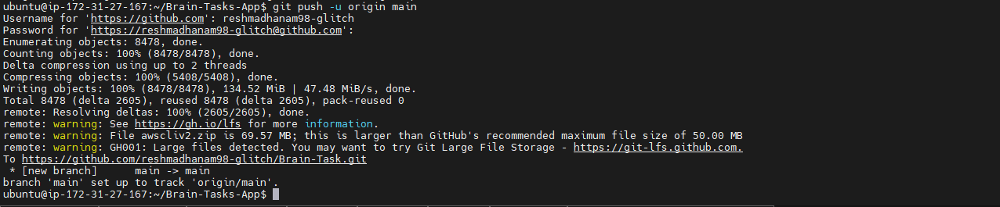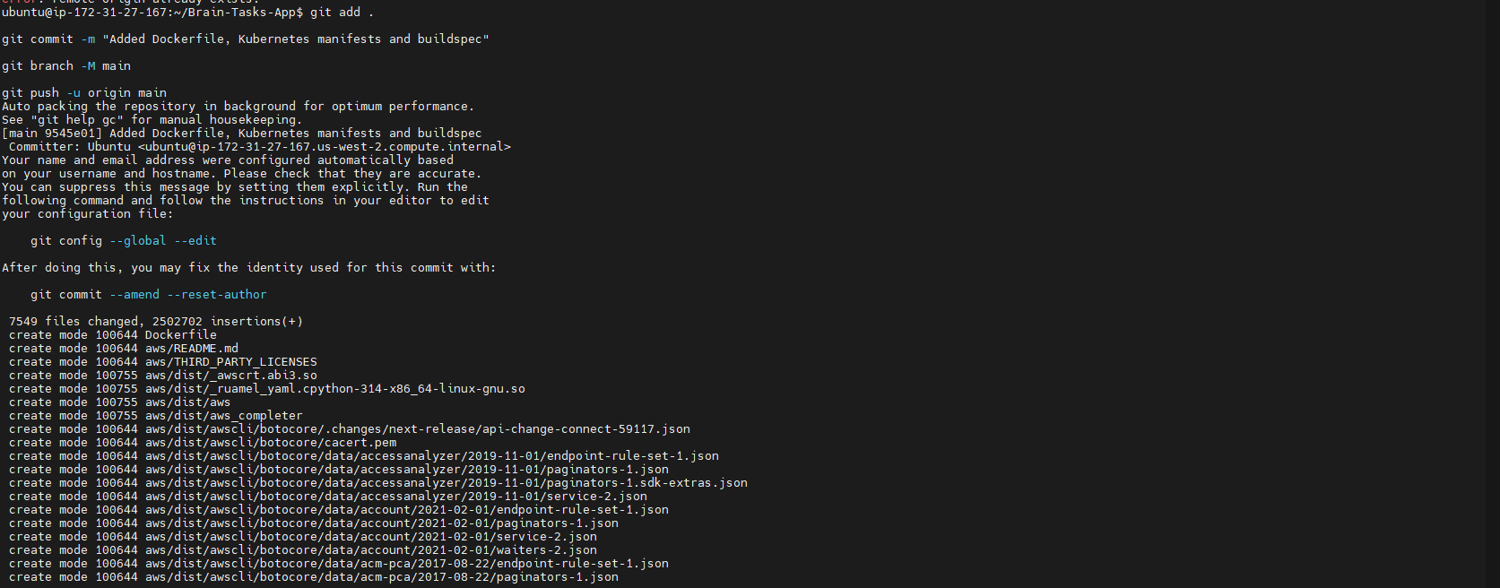
Step 11: Create buildspec.yml:
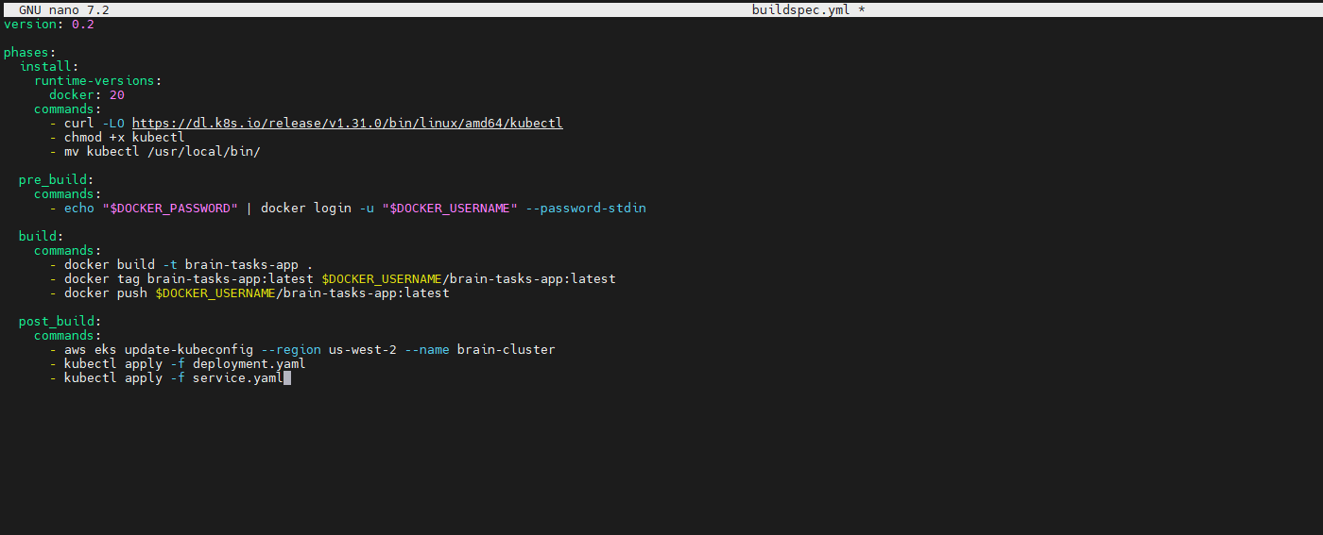
Step 12: Create CodeBuild Project:
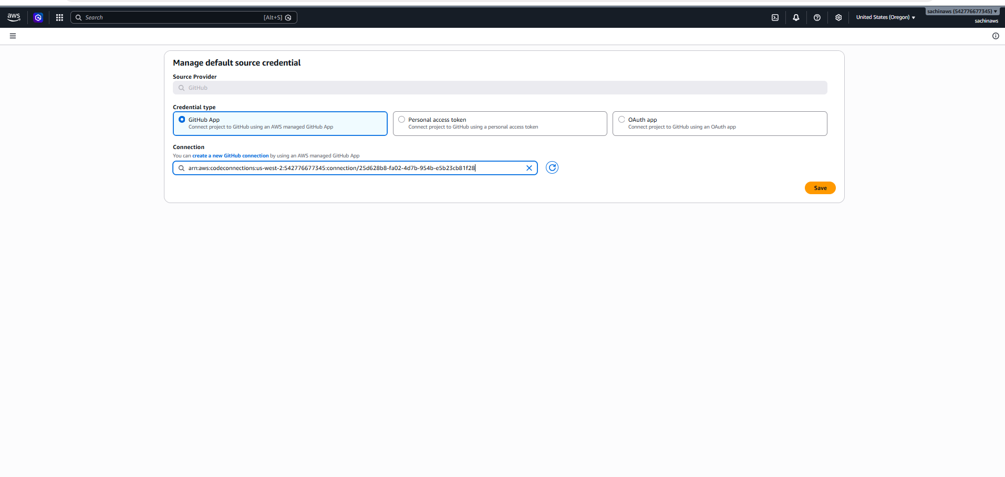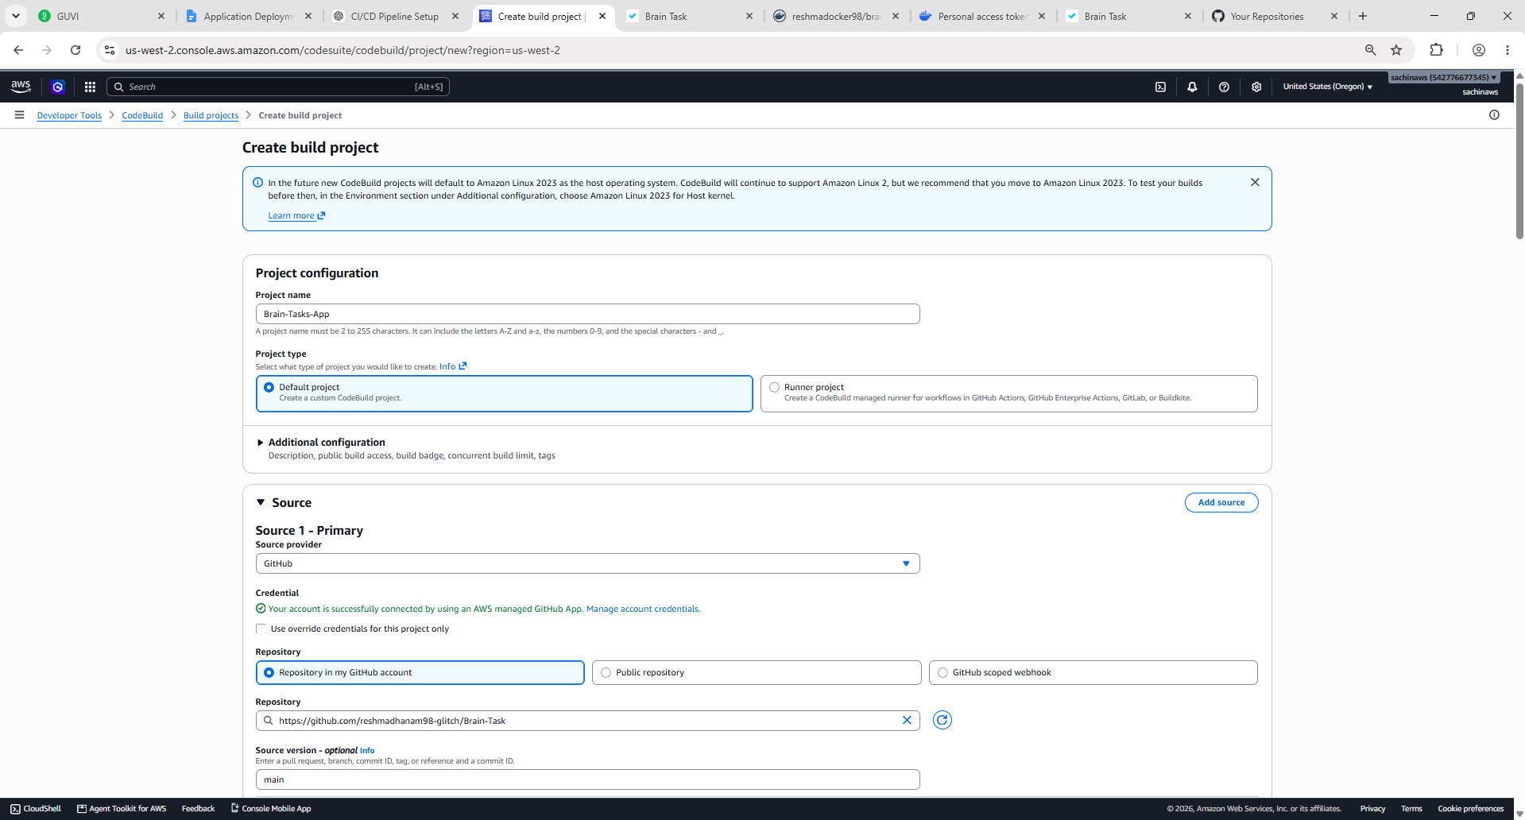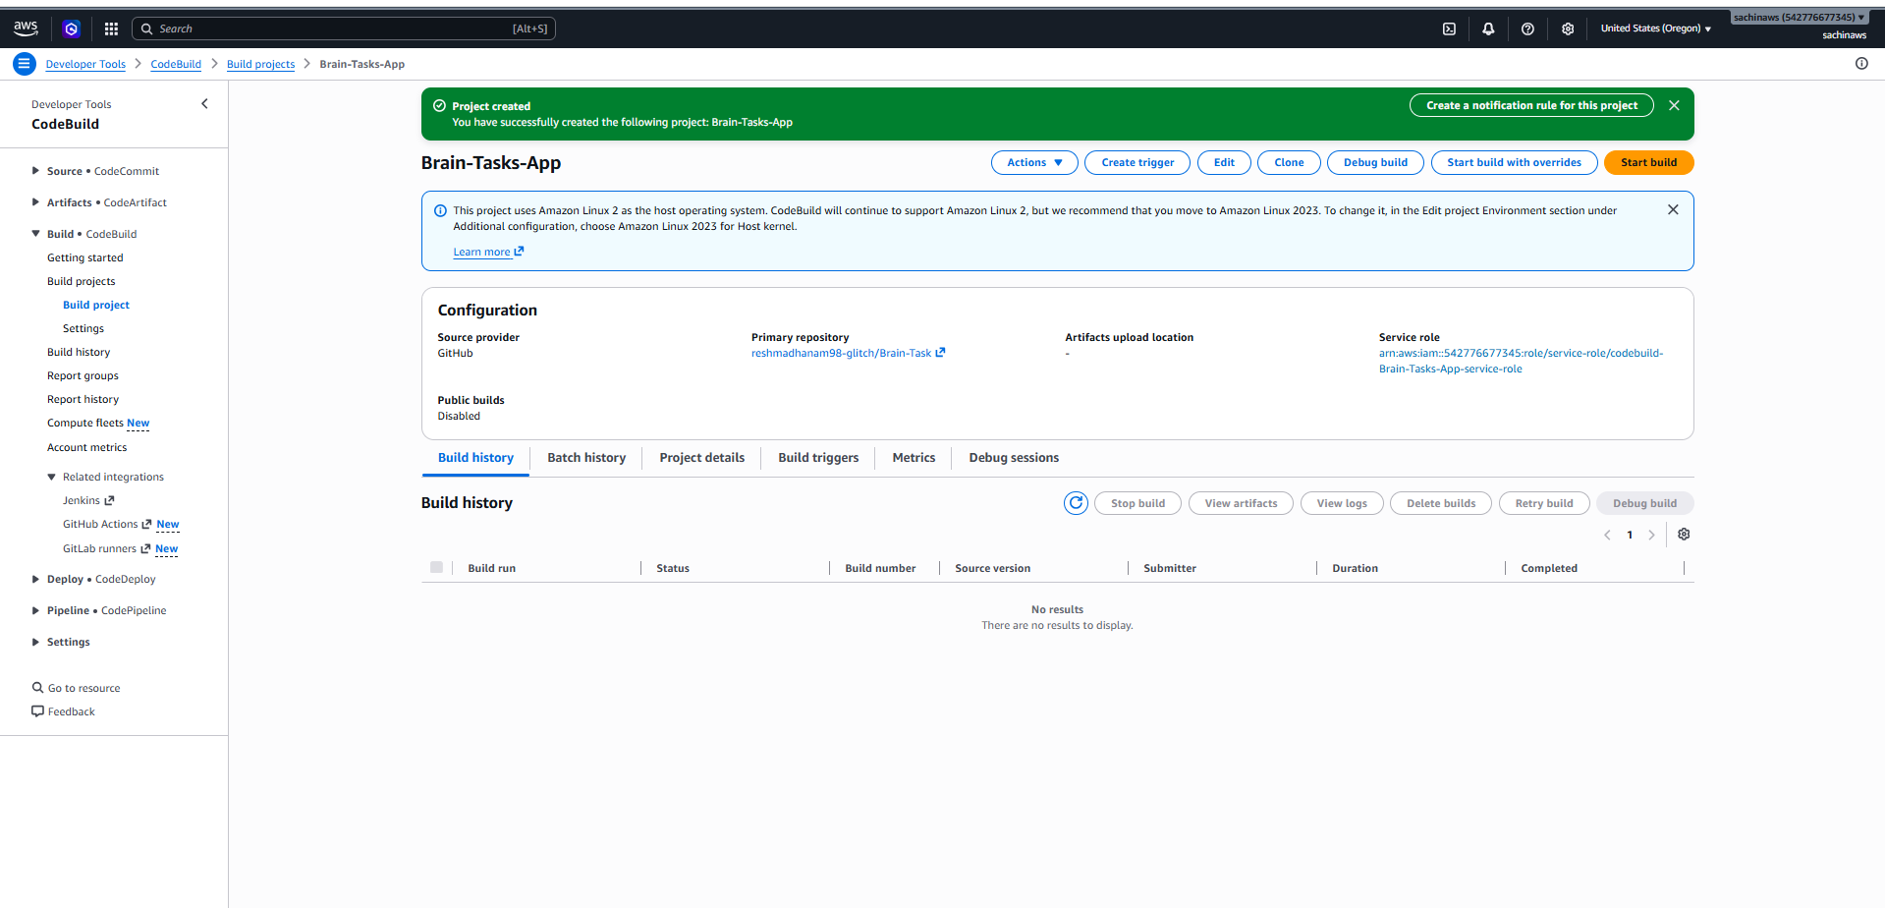
Step 13: Create CodePipeline:
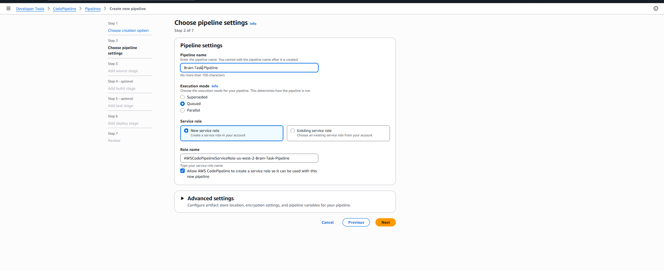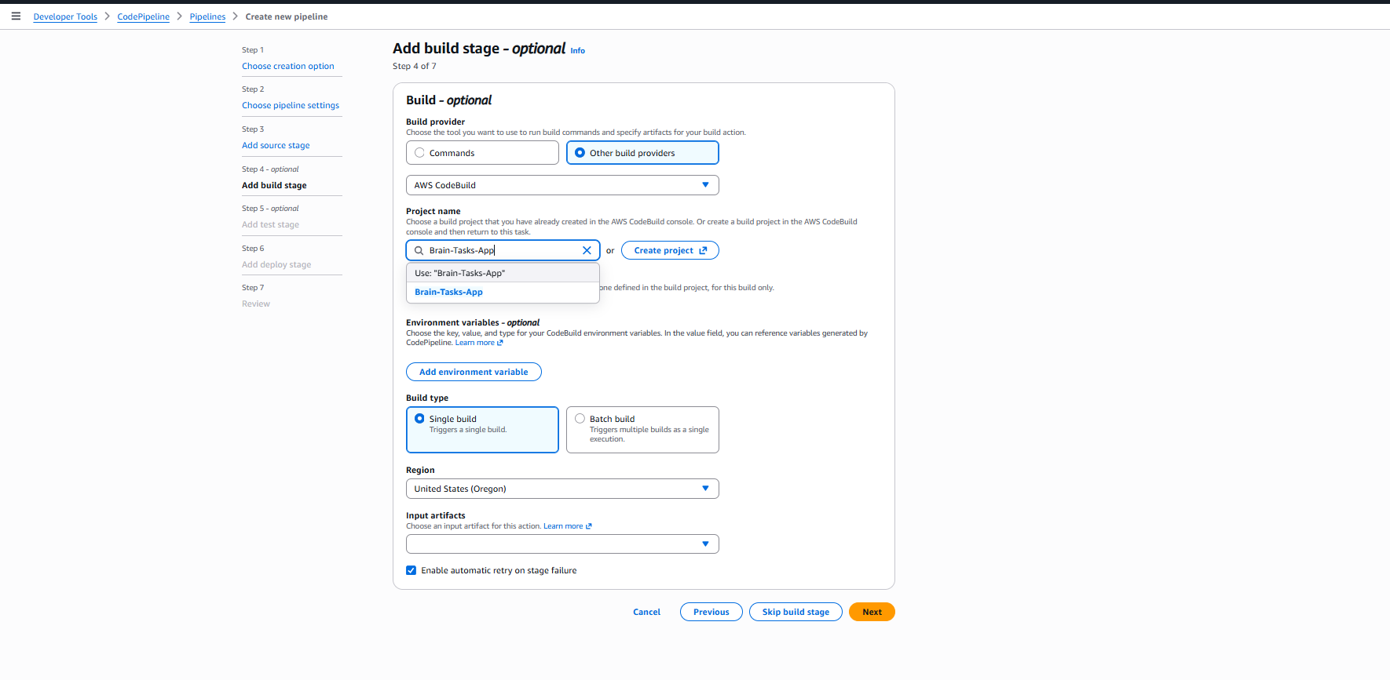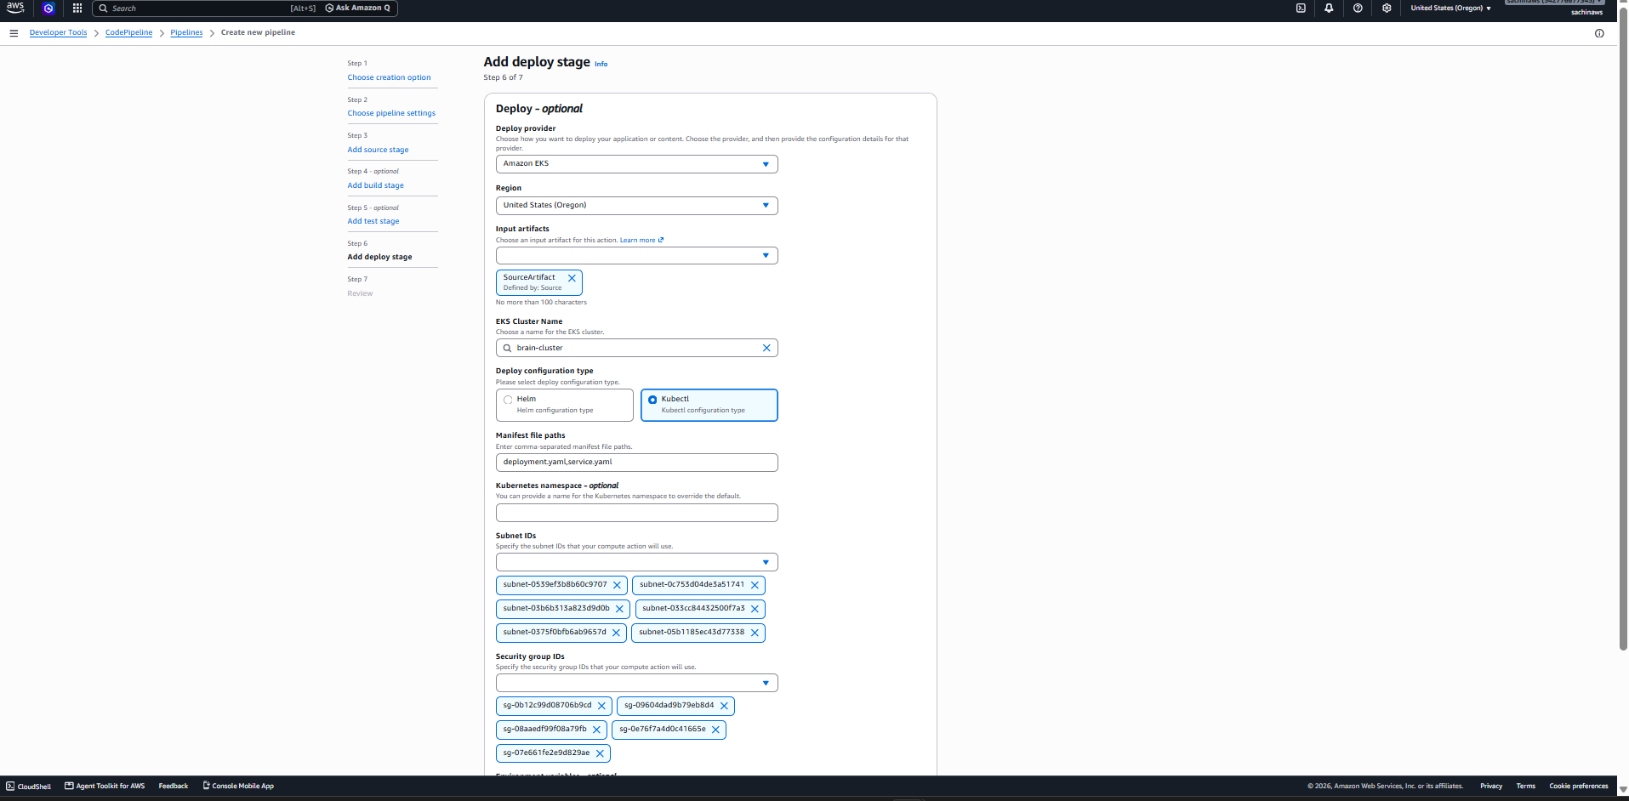
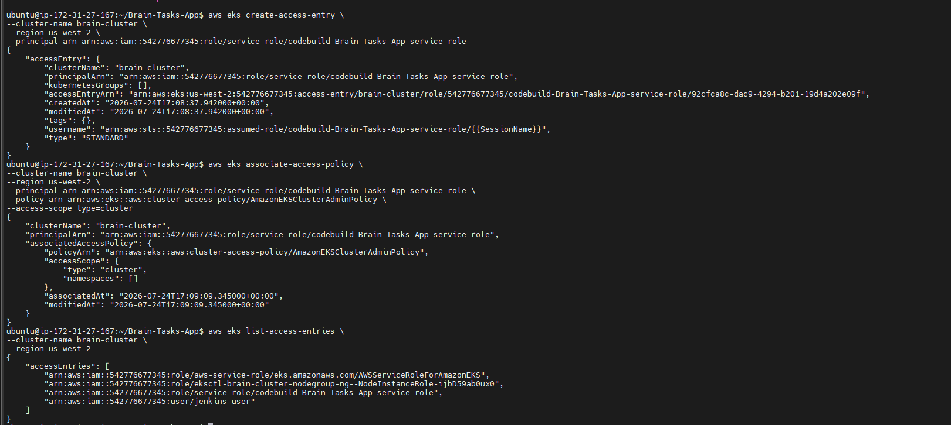
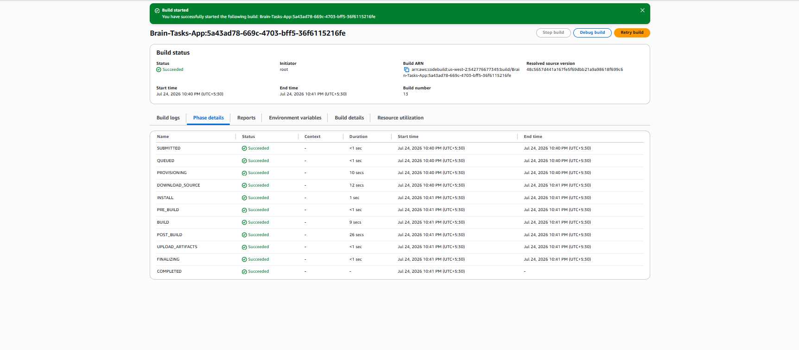
Step14: Monitoring:
Cloudwatch:
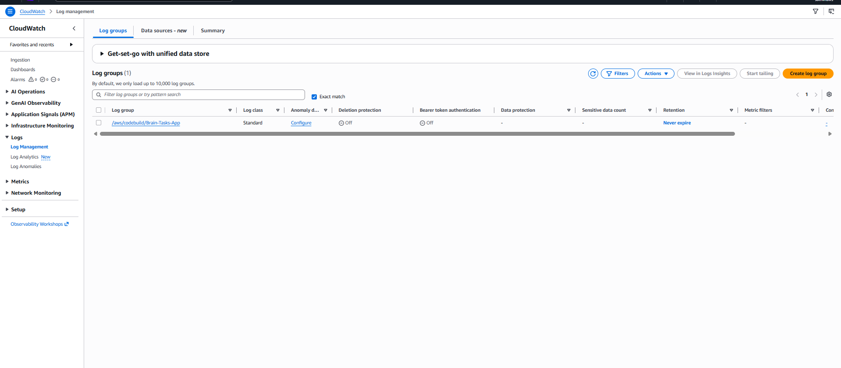
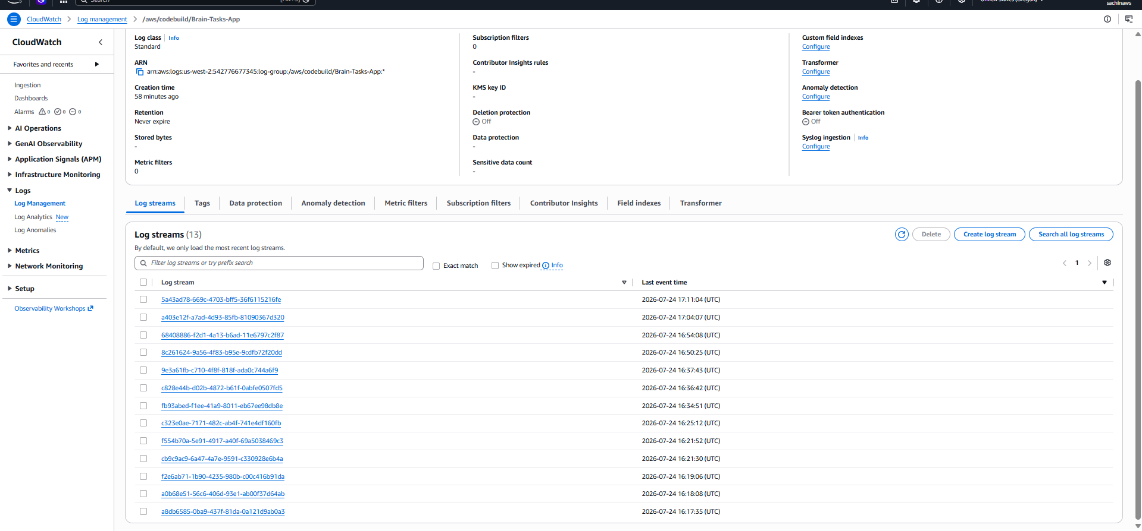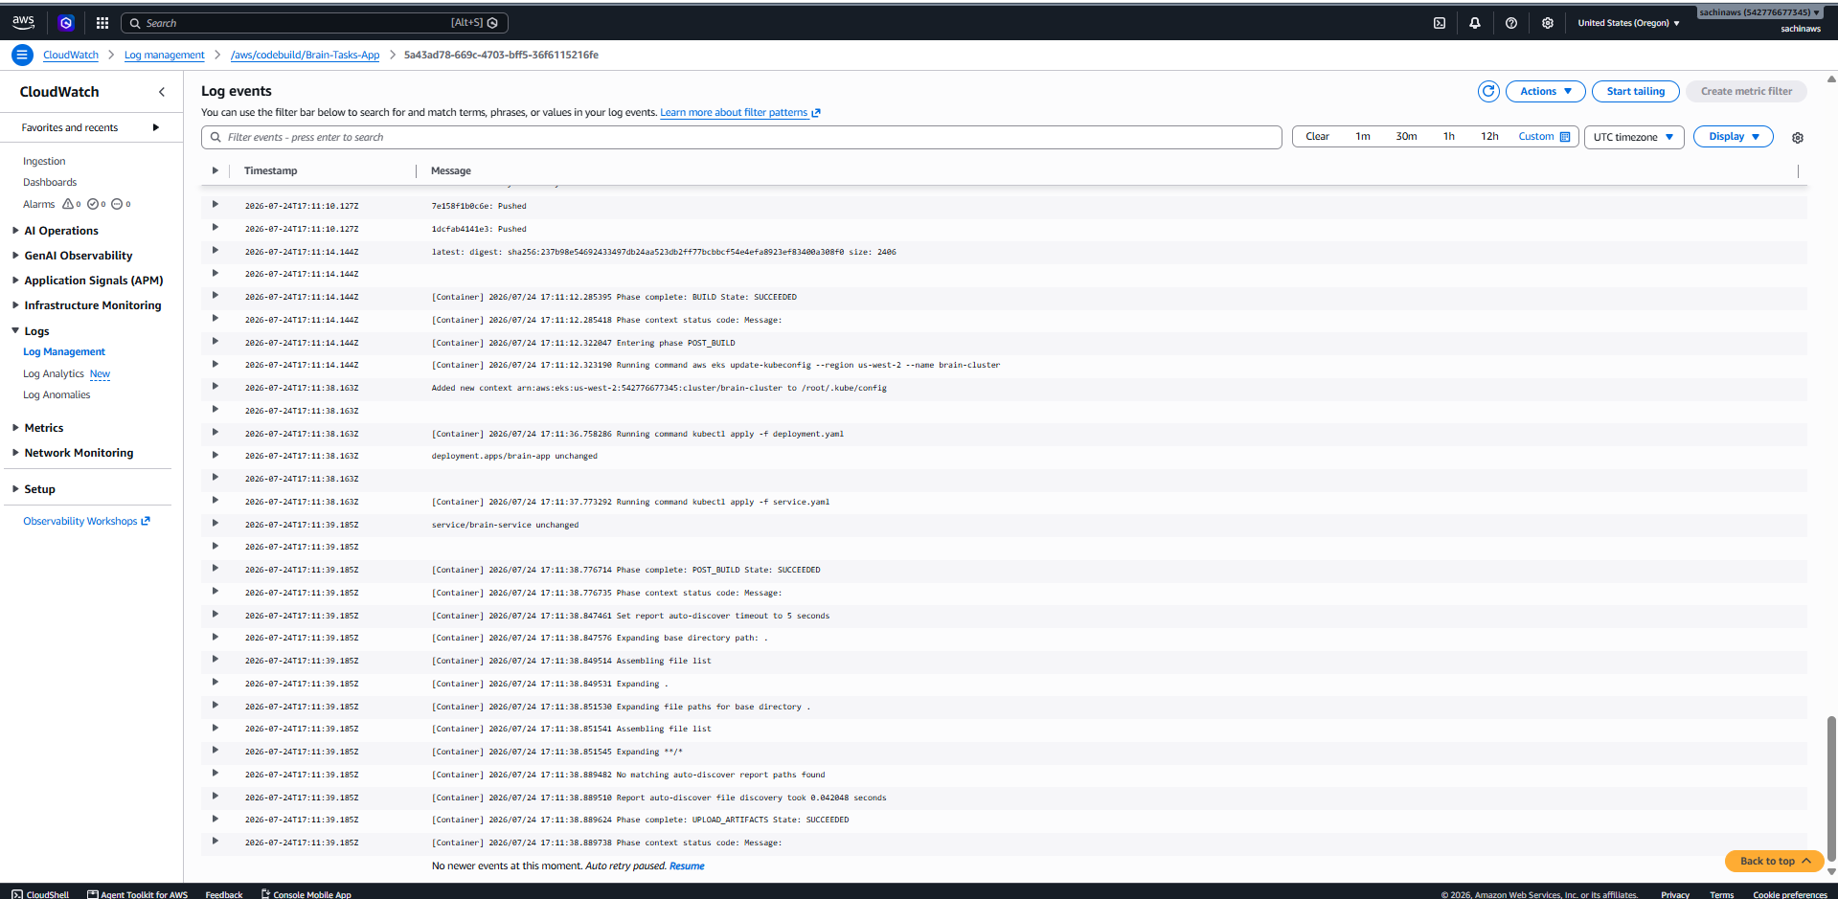
Monitor CodePipeline Execution:
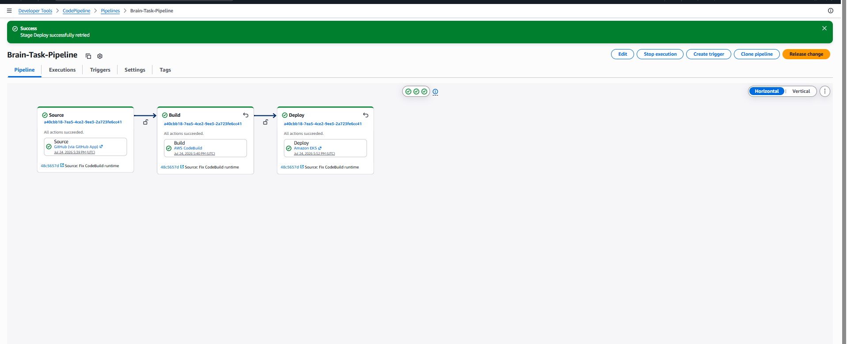
Monitor Kubernetes Deployment Events:
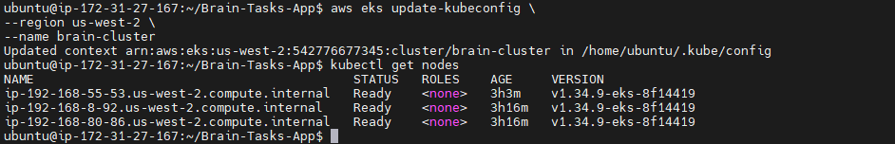
Check Application Pods
View Pod Events
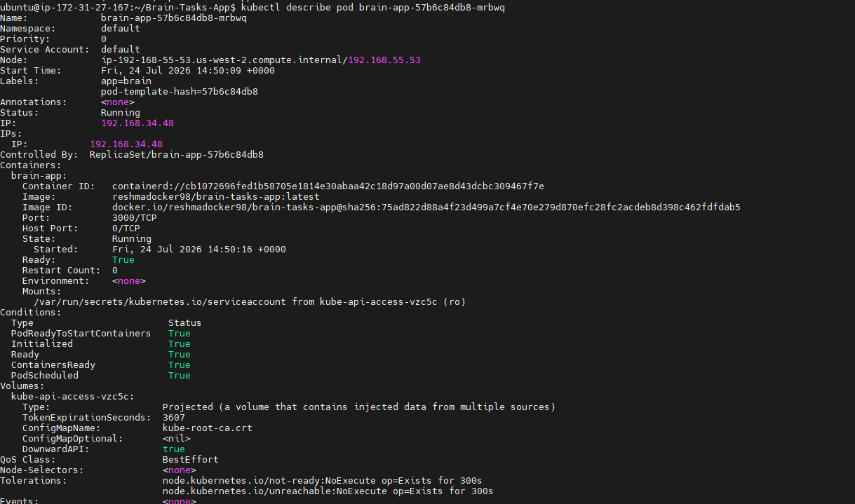
Monitor Application Logs from EKS:
